

Access Valve CTM Automation

Saxion Enschede
Academie Life Science, Engineering & Design
Minor Industrial Automation
7500 KB, Enschede

MiniValve
Lubeckstraat 21
7575 EE, Oldenzaal

Project client: Tom Asbroek
Students: Bart Grootte Bromhaar 536988
Gerrald Boskers 552049
Rik Sluiter 512252
Quinten Warmink 555861

Project Plan
Date: 16-9-2025
Version: 0.1
Version control
Version | Date | Author(s) | Changes compared tot he previous version
0.1 | 16-9-2025 | Everyone | Initial version.

Table of contents project plan
Table of contents project plan 3
1. Project assignment 4
2. Project activities 5
3. The products 6
4. Project boundaries 7

1. Project assignment

Begin situation
MiniValve produces miniature valves, some of these valves need to be lubricated using CTM oil. The lubricating of the valves is done manually. MiniValve has asked for a proof of concept/principle with the goal of automating the process of lubricating the valves.

Assignment description
MiniValve wants a solution for automatically handling these silicone valves and the piercing of the product. The solution needs to be able to lubricate the small openings in the valves with different dimensions. The installation also needs to be future-proof so new products can also be processed with the machine.

Scope of project
The project objective is to automate the lubrication of the valves. This doesn’t include the transport between machines outside of the lubricating process. If the main project is completed and there is still time remaining the transportation between machines can be looked at.

Goal
The goal of the project is to automate the process to lubricate different types of valves with CTM oil to reduce the labour intensity and increase the quality of the lubricated valves.

Project result
The most important part of the result is a proof of concept/principle. Besides the proof of concept/principle there will also be a final PowerPoint presentation and a 3-D model of the setup. Depending on the things that will happen during the project there may also be additional documentation.

2. Project activities

During the project there will be worked following the V-model. During this the team starts with setting up the system requirements.
After these are set, the team starts with putting down the functions in a functional design. In this design the possible solutions for functions will be discussed. When this is done, a concept will be made after choosing the best solutions per function.
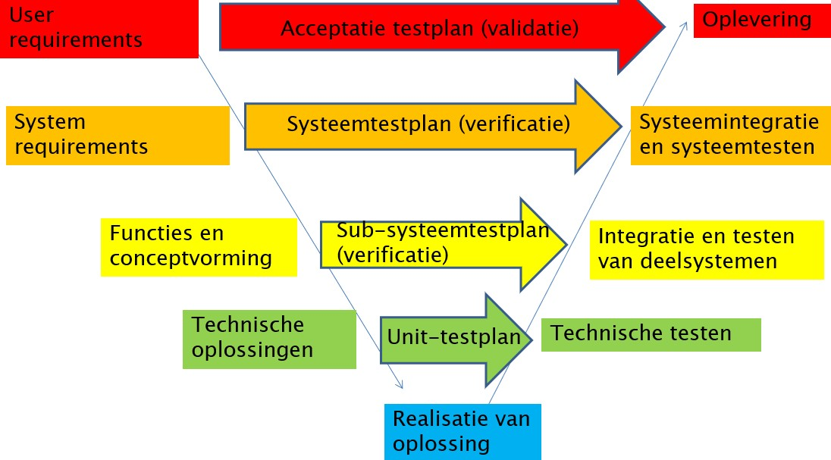
If a concept is made the team will create a technical design.
Figure 1 V-model
If the technical design is created all the parts and functions are known for the 3d-design and the team will create a realistic 3d solution for the project.
Where needed there will be looked at testing parts of the design.

3. The products

During this project there will be several products that will be delivered to the client. This way there will be a good verification on the work being done. The products that will be delivered:

- Project plan.
Document which describes the assignment and the general flow of the project.

- Functions document.
Document with the main- and subfunctions of the system (such as the IDEF0).

- Requirements document.
Document with the requirements that are set for the project.

- Functional/concept design.
Document with a concept and functional design for the system.

- Test Plan.
Document with a test plan and test results.

- Proof of principle.
Document with proof that the designed system is working.

4. Project boundaries

Project length
The project starts at 01-09-2025 and ends at 15-01-2026.

Project width
The project contains the development of the system to lubricate valves with different dimensions. The project product can improve the quality of the lubricated valves, but won’t apply any changes to the valves.
- The build of the system is defined.
  - During the project there must be accounted with a modular build of the system, for possible future projects of the system.
- The different types and sizes of the valves are defined.
  - Types of valves: xxx
  - Minimum diameter valve is xxx.
  - Maximum diameter valve is xxx.
  - Minimum diameter needle valve is 0,5 mm.
  - Maximum diameter needle valve is 3 mm.
  - Minimum thickness valve is xxx.
  - Maximum thickness valve is xxx.

Project boundaries
What does not need to be met during the project:
- The way of feeding the valves to the system outside of the lubricating process.
- The quality control on the lubricated valves.
- The realising of the physical system.

Proposal approval

□ GO □ NO GO

Date:

Signature of client Mr. T. Asbroek:

Considering contractors group 9:

